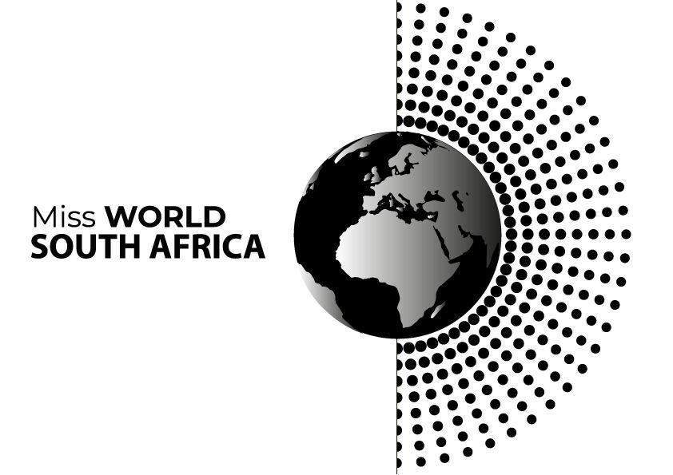

MISS WORLD SOUTH AFRICA FINALS TO BE HELD IN SUN CITY IN OCTOBER
JOHANNESBURG, 11 September 2024 - The 2024 Miss World South Africa pageant featuring 10 hopefuls will take place on Saturday, October 5th in Sun City, Pilanesburg, North West Province.

The winner will represent South Africa at the Miss World finals in February 2025. The venue will be announced by the London-based Miss World Organisation soon.

“I am excited about the second edition of Miss World South Africa will be held in Sun City. The finalists are just sublime and we wish them all success as we know they are primed to be successful leaders of the future,” said Carol Bouwer, the license holder of Miss World South Africa and President of Miss World South Africa Organisation.

The finalists are:
- Nande Mabala, 26 a model, social and media entrepreneur from Cape Town, Western Cape,
- Lynique Odendaal, 22, a music therapist from Wonderboom, Pretoria, Gauteng,
- Tshiamo Setlhare, 26, an Occupational Therapist from Mahikeng, North West,
- Neo Nkhumane, 22, a Communications lecturer at North-West University;
- Ximiyeto Makhubele, 21, a tech developer from Giyani, Limpopo,
- Romanda Hombir, 25 a Clinical Audiologist from Gauteng;
- Zoalize Jansen van Rensburg, 18, a digital and marketing executive from Pretoria, Gauteng,
- Amber Marais, 22, from Bloemfontein, Free State,
- Thembelihle Mnguni, a 25 year-old model and Electrical Engineering student from KwaZulu-Natal and
- Jesmika Singh, 25, a University of Cape Town Masters student from Kwazulu-Natal.

Pictures and profiles of the contestants are available on www.missworldsa.com

Tickets for MWSA are available on https://www.quicket.co.za/events/277501-miss-world-south-africa/?ref=algolia-search#/tickets

Miss World, the 72 year old global organisation which will soon announce the date and venue of the finals, has used the Beauty with a Purpose ethos to raise money for organisations that support disadvantaged and disabled children and other deserving causes.

Contact details: media@missworldsa.com
Cell: 083 2010 254
Rich Mkhondo
Issued by Carol Bouwer Productions
www.missworldsa.com

Issued by Carol Bouwer Productions

